Program Name: STEM Fundamentals and Simple Machines
Grades Applicable: Grade: 1 and 2
Fee: Rs 10000/‐ (Includes cost of Take Home STEM kit and delivery charges)
No of sessions: 24
Total Projects: 12-15
Register HERE
Happy To Help: 77770 54033 / 77770 54233

Grades 1 & 2 – STEM Fundamentals and Simple Machines
Program Highlights
▪ Introduces students to the basic concepts of engineering, science and Maths through
practical projects, with help of interactive media like PPT videos gif’s, quizzes and activities.
▪ Children explore STEM concepts by carrying out simple interesting projects, in a safe,
hands-on and exploratory manner.

Learning Targets

- STEM Fundamentals course provides an ideal  first step in the introduction to STEM education. | 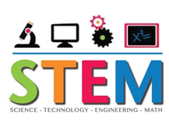
- Enhances understanding of modern day
technology and its applications
- Increases Curiosity and understanding of how
thing function in real life.
- Design and make things for different purposes
- Explore and execute ideas

Register HERE

Program Name: Electrics and Circuits
Grades Applicable: Grade: 3
Fee: Rs 10000/‐ (Includes cost of Take Home Electrics kit and delivery charges)
No of sessions: 24
Total Projects: 16
Register HERE
Happy To Help: 77770 54033 / 77770 54233

Grade 3 - Electrics and Circuits

Program Highlights
- An innovative and education based program designed to teach children the basic principles of electricity and electronics in a fun way.  - Children can explore electronics and electricity,  by designing virtual and physical circuits and see the live working of the various components and application based circuits. | 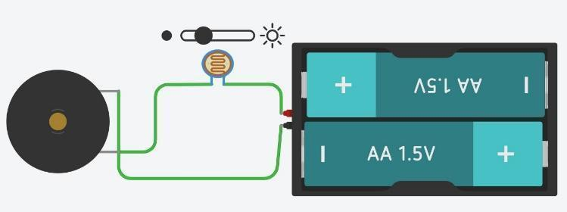
Learning Targets

- Learn about electric circuits(series and parallel)
- Find out about AND /OR gates
- Learn about and use different types of switches
- Learn basics of Resistors, LED, Capacitor &Photo resistor
- Create Electronic Games and Alarms

Register HERE

Program Name: Arduino Programming
Grades Applicable: Grade: 6
Fee: Rs 10000/‐ (Includes cost of Take Home Arduino kit and delivery charges)
No of sessions: 24
Total Projects: 12
Register HERE
Happy To Help: 77770 54033 / 77770 54233

Grade 6+ – Arduino Programming

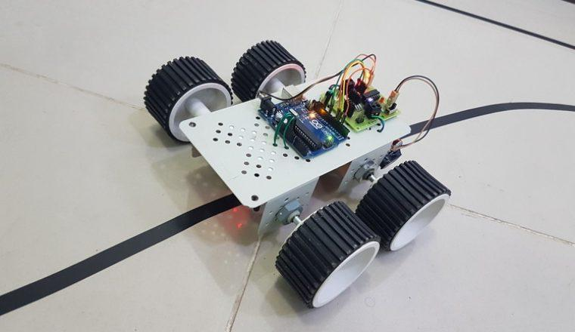
Program Highlights

- Arduino is an open-source electronics platform based on easy-to-use hardware and software.
- It is a program that integrates all aspects of STEM education.
- It's intended for anyone making interactive electronic projects and robots.
- It introduces kids to Electricity and Electronics, Coding and Robotics.

Learning Targets
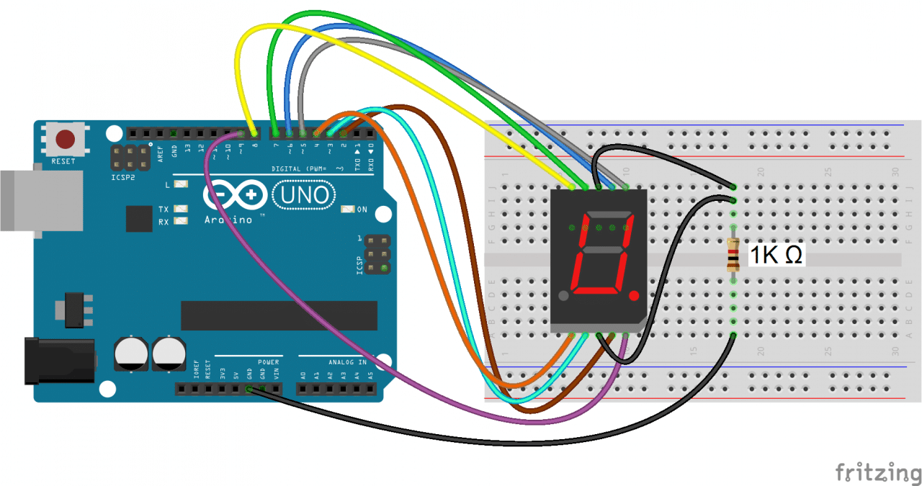
- Learn Electronics using Arduino, an open-source electronics platform based on easy-to-use hardware and software, along with introduction to various sensors helping them build and program their own robot.
- Introduction to coding using C++ programming
- Learn how to read inputs - light on a sensor, a finger on a button, or a Twitter message - and turn it into an output - activating a motor, turning on an LED, publishing something online.
- Learn different electronic components and the way it can be programmed through Arduino IDE.

Register HERE
Program Name: IoT(Internet of Things)
Grades Applicable: Grade: 8+
Fee: Rs 10000/‐ (Includes cost of Take Home Electrics kit and delivery charges)
No of sessions: 24
Total Projects: 14
Register HERE
Happy To Help: 77770 54033 / 77770 54233

Grade 8+ - IoT(Internet of Things)

Program Highlights
- IoT makes everyday objects 'smart' by enabling them to transmit data and automate tasks, without requiring any manual intervention. An IoT device could be something as simple as a health tracking wearable, or as complex as a smart city with sensors across all its regions.  - Children Learn to collect and transfer data over a wireless network without human intervention for security systems using The Internet of Things (IoT) | 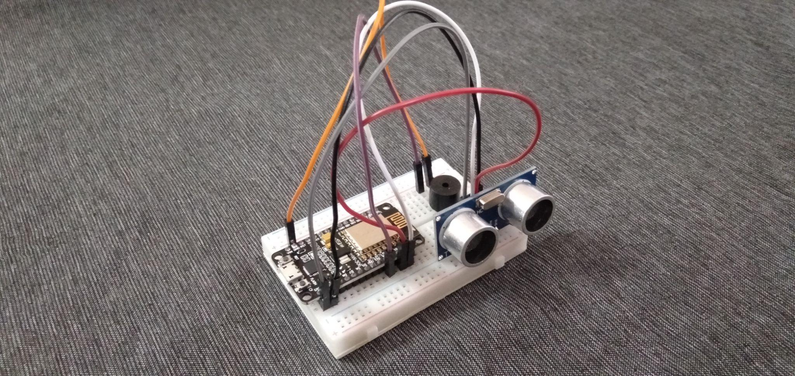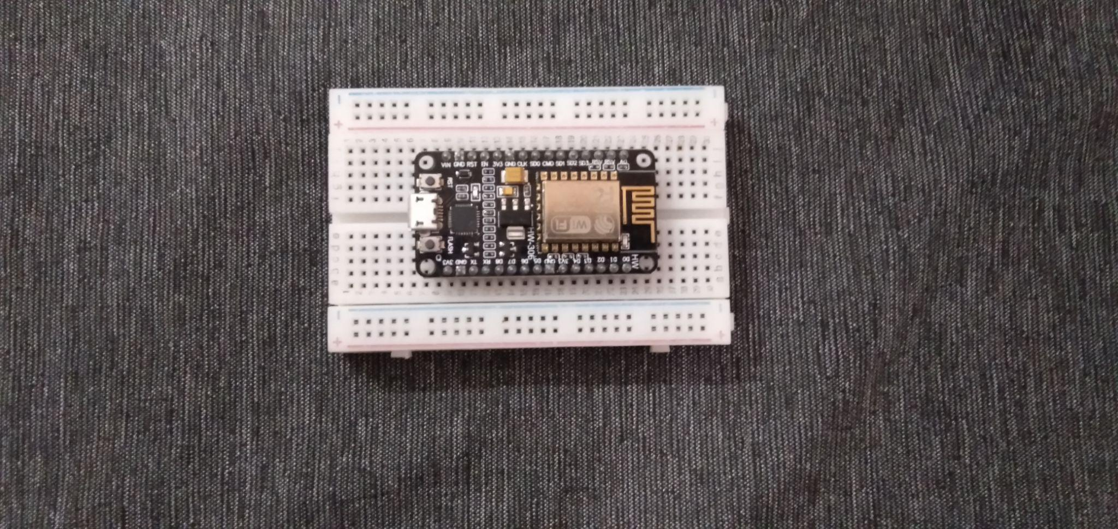
Learning Targets
- Learning IoT in the most fun and interactive way.
- Learn how to create different smart Projects which will be connected over internet to exchange information.
- Learn how to create project in blynk app for exchanging information to different devices.
- Learn how to develop projects like Anti theft door security, Locker Security, Smart Agriculture, Smart Dustin,Smart attendance etc

Register HERE

Program Name: App Magic
Grades Applicable: Grade: 4
Fee: Rs 7500/‐
No of sessions: 24
Total Projects: 11
Register HERE
Happy To Help: 77770 54033 / 77770 54233

Grade 4 – App Magic - Building Mobile Applications

Program Highlights
- Helps channelize Children’s natural affinity to screens in a positive manner where they bring their personal ideas come to life through programming & app building.
- Children become media producers rather than media consumers.
Learning Targets

- Express their creativity and imagination using coding and technology
- Solve a variety of problems encountered in their projects
- Making exciting, personal ideas come to life through coding
- Seeing the output of their code as an app on any mobile device
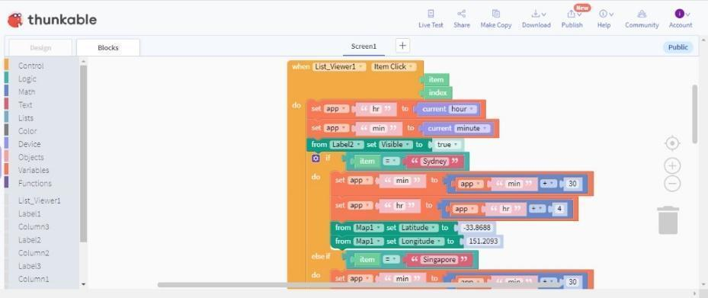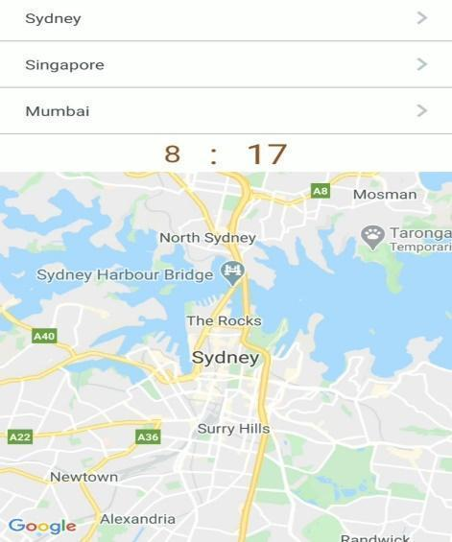

Register HERE

Program Name: HTML & CSS
Grades Applicable: Grade 5 & 6
Fee: Rs 7500/‐
No of sessions: 24
Total Projects: 14
Register HERE
Happy To Help: 77770 54033 / 77770 54233

Grade 5 & 6 - HTML and CSS -Introduction to the World of Web Designing and Programming
Program Highlights

- HTML stands for “HyperText Markup Language” and is the language for creating webpages with text, paragraphs, headers, links, pictures, and even sound and video.
- HTML is the foundation of Web Designing.
- Easiest to learn and makes advanced languages easier to learn.
- Powers Creative Thinking of a Child in representing his ideas and imagination on the webpage layout and design.
- Enable children to create their websites and also start a career on the web & design space

Learning Targets
- Introduction to HTML, Elements, Tags and their Attributes.
- Cool and Fun HTML Elements for your website.
- Learn how to design and program different types of websites
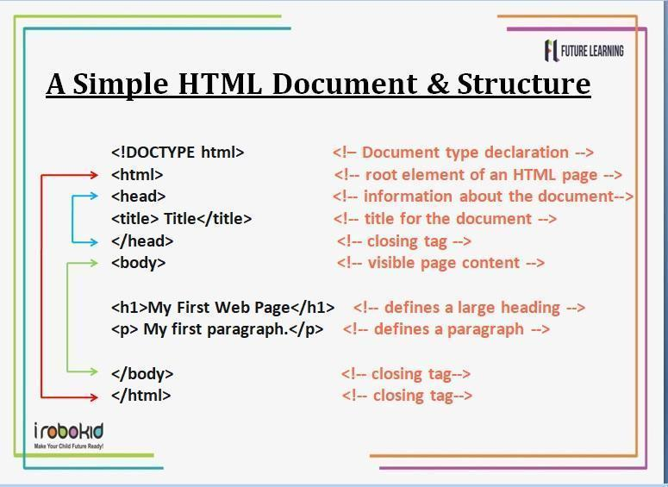 | 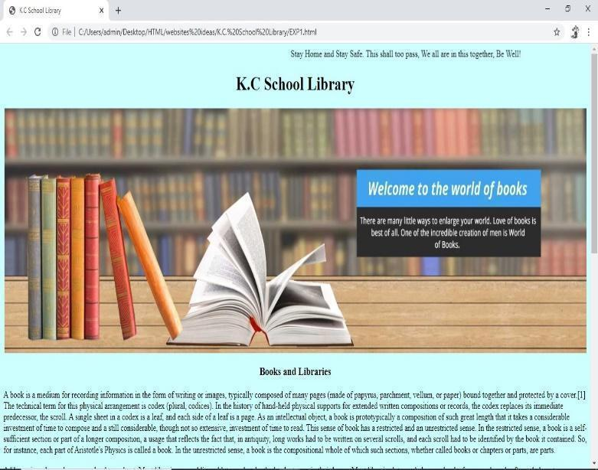
Register HERE

Program Name: Coding, AI and Teachable Machines
Grades Applicable: Grade 5+
Fee: Rs 7500/‐
No of sessions: 24
Total Projects: 18
Register HERE
Happy To Help: 77770 54033 / 77770 54233

Grades 5 & 6 -Coding, AI and Teachable Machines
Program Highlights

- An ideal first step in introducing coding to first time programmers. It has a simple drag and drop interface and helps develop the logic needed for programming as well as boosts the creativity and design skills of the child.
- This course is a unique combination of learning to design and code games and short animated movies as well as understanding basic concepts of Artificial Intelligence and seeing its implementation in simple AI projects.

Learning Targets
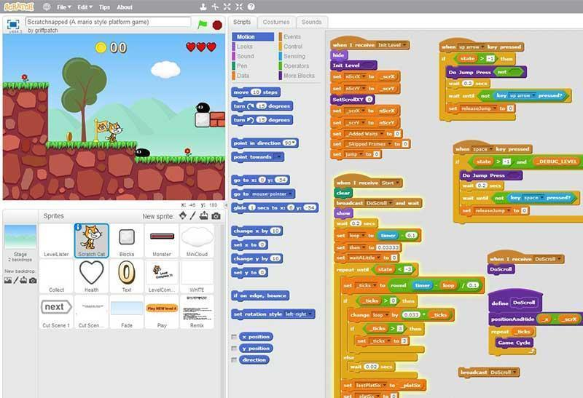
- Learning the basic principles of programming.
- Work individually or collaboratively to design a game, animation and story.
- Learn important computational skills and concepts that will be of help when solving programming problems.
- Understanding what is AI (Artificial Intelligence) and learning simple concepts of AI and see implementation in some of the projects.
- Understanding concept of teachable machines, how to teach and train the machine by providing various data samples and generate desired output for different projects.

Register HERE

Program Name: Python Programming
Grades Applicable: Grade: 7
Fee: Rs 7500/‐
No of sessions: 24
Total Projects: 14
Register HERE
Happy To Help: 77770 54033 / 77770 54233

Grades 7 - Python Programming

Program Highlights
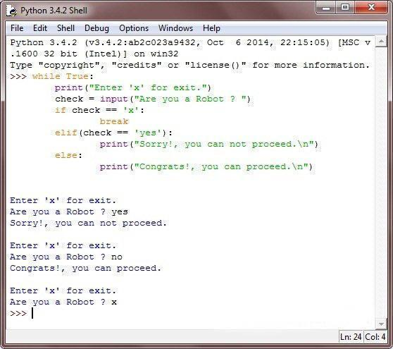
- Python is a revolutionary and easy to learn programming language having applications in Data Science and Analytics, Machine Learning, Automation and Computing.
- This educational tool provides students with an introduction to code level programming, I/O, and visualization using the Python programming language.
- Python allows developers to write programs with fewer lines than some other programming languages.
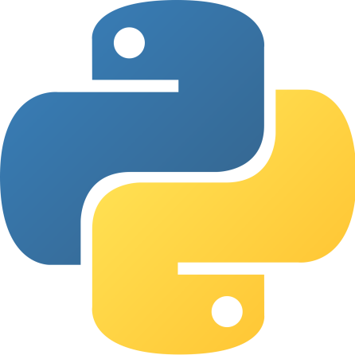
- Python turns kids from media consumers to media producers
- Children learn software development, mathematics, system scripting.

Learning Targets
- Learn how to design and program Python applications
- Define the structure and components of a Python program.
- Learn how to write loops and decision statements in Python.
- Learn how to use lists, tuples, and dictionaries in Python programs.
- Learn how to build and package Python modules for reusability.

Register HERE

Program Name: Java Programming
Grades Applicable: Grade: 8+
Fee: Rs 7500/‐
No of sessions: 24
Total Projects: 17
Register HERE
Happy To Help: 77770 54033 / 77770 54233

Grades 8+ - JavaProgramming

Program Highlights

- Java is one of the world’s most popular programming language | 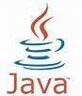
- Java makes easier to learn other languages in future

- Java is a platform-Independent language which execute on any platform & any operating system.

Learning Targets

- Introduction to Java basics like Variable, Data Type, Operators, Conditional Statement, Conditional Looping Statements, Escape And Selection Statements etc.
- Introduction to Advance Java features like Array, String and Math class, Methods, object oriented programing, Inheritance etc.
- Design and code wide range of games and applications using java code.

Register HERE

